**EXP :7**

**DATE : 10-02-2023**

**CREATE A STORAGE SERVICE USING ANY PUBLIC CLOUD SERVICE PROVIDER (AZURE) AND CHECK THE PUBLIC ACCESSIBILITY OF THE STORED FILE TO DEMONSTRATE STORAGE AS A SERVICE.**

**AIM:**

To Create a storage service using any public cloud service provider (azure) and check the public accessibility of the stored file to demonstrate storage as a service.

**PROCEDURE:**

1. Open azure and go to storage accounts and create storage account
2. Enter the resource group and storage account name and review and create and click the create and your storage account will be deployed successfully.
3. And our storage account is created.
4. Go to static website
5. Enable and enter your index and error html files names.
6. Go to storage explorer(review) and go to blob containers and web and upload the two html files
7. Again return to storage and open your file

**IMPLEMENTATION:**

**STEP1: OPEN AZURE AND GOTO STORAGE ACCOUNTS AND CREATE STOROAGE ACCOUNT**

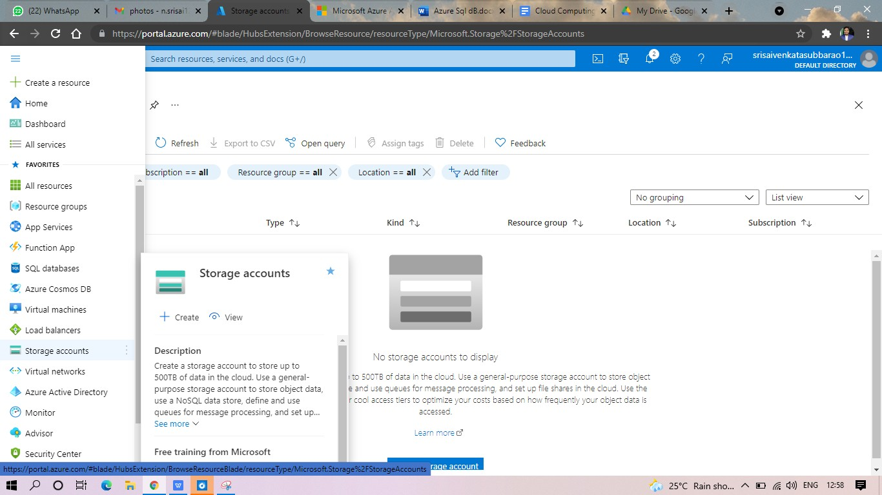

**STEP2: ENTER THE RESOURC GROUP AND STORAGE ACCOUNT NAME AND REVIEW AND CREATE AND CLICK TH CREATE AND YOUR STORAGE ACCOUNT WILL BE DEPLOYED SUCCESSFULLY** 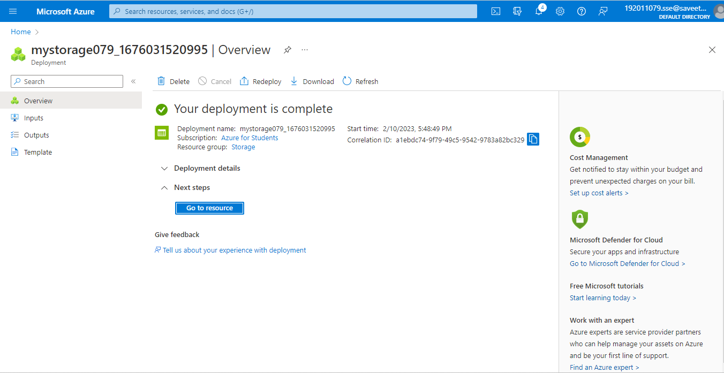

**STP3: AND OUR STORAGE ACCOUNT IS CREATED.**

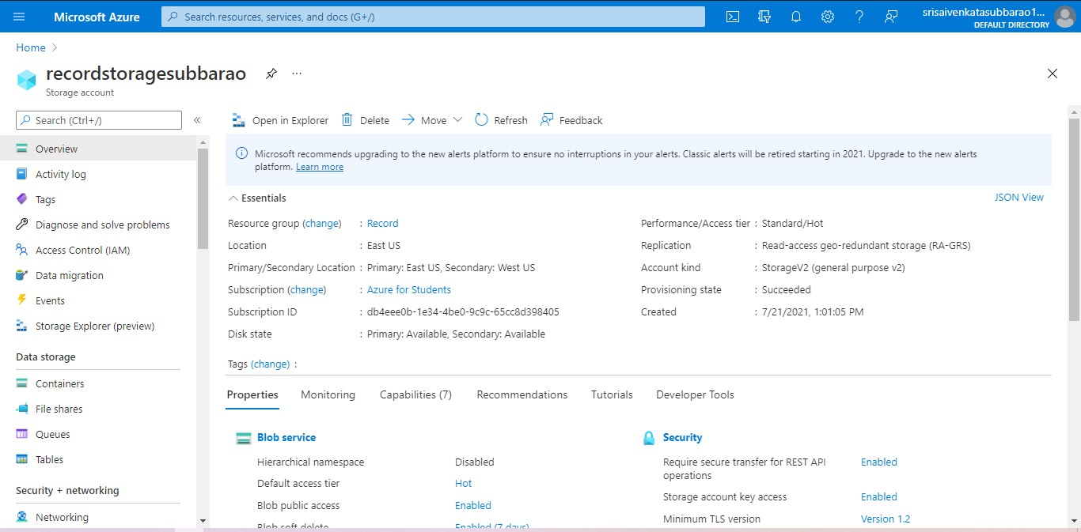

**STEP5: GOTO STORAGE EXPLORER**

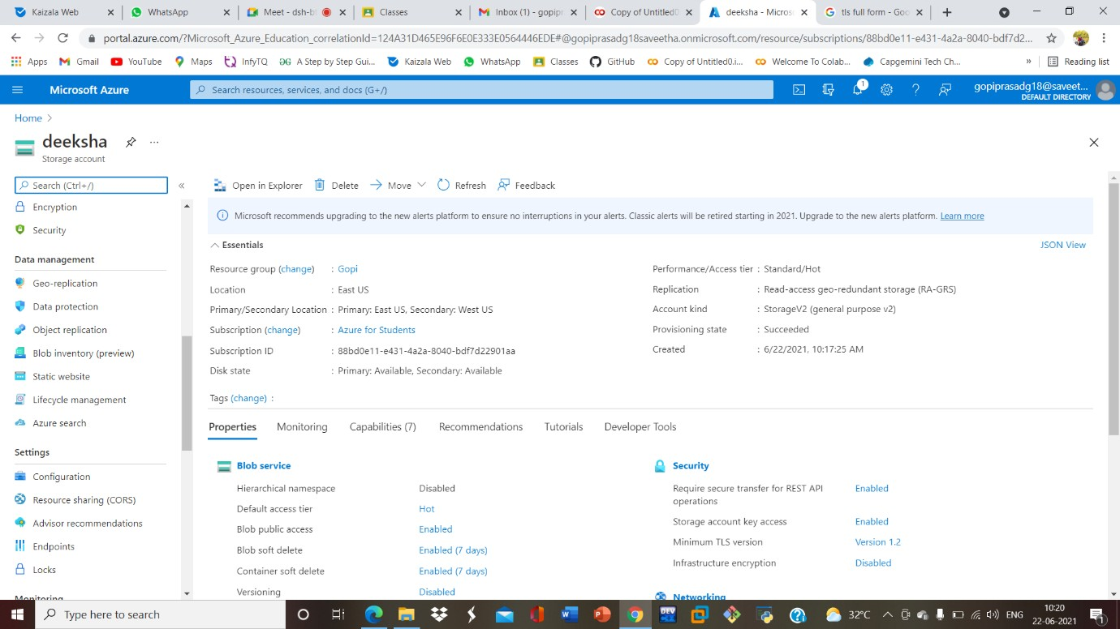

**STEP6: AND ENABLE AND ENTER YOUR INDEX AND ERROR HTML FILES NAMES.**

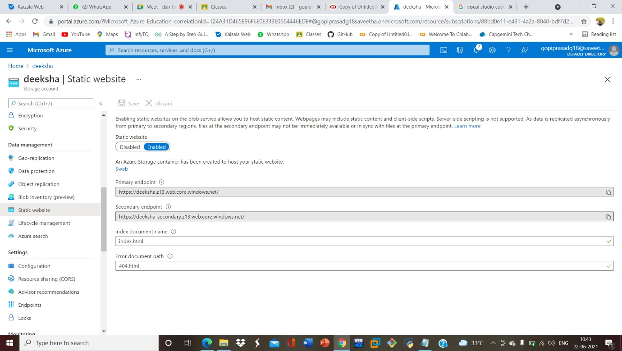

**STEP7: AND GOTO STORAGE EXPLORR(REVIEW) AND GOTO BLOB CONTAINERS AND WEB AND UPLOAD THE TWO HTML FILES**

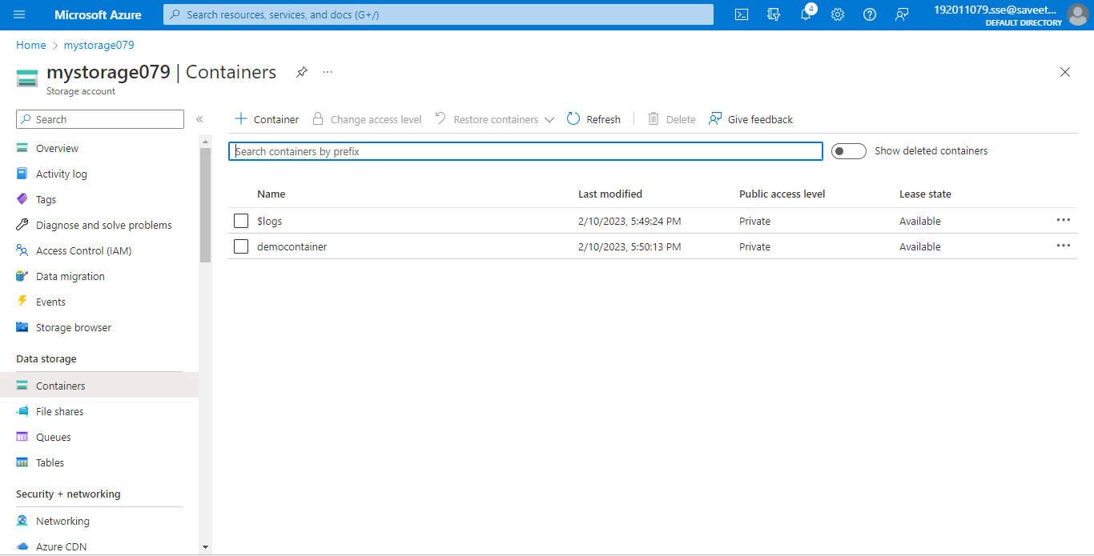

**STEP8: AND AGAIN RETURN TO STORAGE YOU CAN SEE YOUR UPLOADED FILES.**

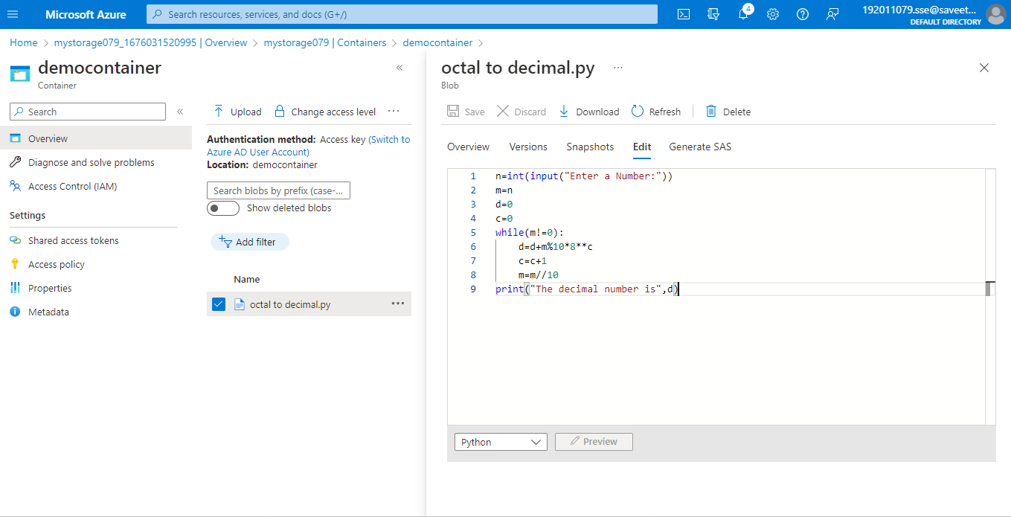

**RESULT:**

Hence the storage service using any public cloud service provider (azure) and check the public accessibility of the stored file to demonstrate storage as a service is Completed.